DCC-GARCH correlation: AUDUSD and USDJPY
Method 09 / GARCH(1,1) + Engle DCC / Alpari D1 full available history

Study setup
Logical pair: AUDUSD , USDJPY
Broker symbols: AUDUSD_i , USDJPY_i
Snapshot: 2026-11-03_majors_alpari_D1
Timeframe: D1
Matched return window: 1999-01-05 to 2026-11-02 (UTC bar dates)
Matched return count n: 7199
Dropped unfinished last bar dated 2026-11-03 UTC after a tick-volume check against the prior complete day.
AUDUSD GARCH(1,1): mu=0.000038, omega=0.005421, alpha=0.052450, beta=0.936928
USDJPY GARCH(1,1): mu=0.000110, omega=0.005014, alpha=0.052022, beta=0.935293
DCC: a=0.060899, b=0.916242, a+b=0.977141
Burn-in ignored in path summaries and chart: first 60 updates
Complete matched rows (Excel): AUDUSD-USDJPY_DCC_D1.xlsx
Complete matched rows (HTML table): AUDUSD-USDJPY_DCC_D1_data.html

Method carried forward
DCC-GARCH first fits a constant-mean GARCH(1,1) on each matched daily log return of close, ln(close_t / close_t-1), then updates Engle (2002) dynamic conditional correlation on the standardised shocks z = residual / conditional sigma. Quotes are not inverted. Correlation targeting sets Q_bar to the sample correlation of z; a and b are estimated by maximising the bivariate Gaussian DCC likelihood with a >= 0, b >= 0, and a + b < 1. Path summaries ignore the first 60 updates. The headline is rho on the last day. Same-sample Pearson r on log returns is a side check only. A high |rho| does not prove cause, lead-lag, or a trading signal.

Results
Latest DCC rho: -0.151274
Post-burn-in path (n=7139): mean=-0.225422, median=-0.262850, min=-0.748245, max=0.671802, std=0.259844
Share of post-burn-in days with |rho| >= 0.4: 30.12%; |rho| >= 0.7: 0.46%
Same-sample Pearson r: -0.088151
Latest rho minus r: -0.063123

Conclusion
Over 7199 matched daily log-return rows for AUDUSD and USDJPY (broker quote directions unchanged), latest DCC rho is -0.1513 (negative, weak conditional linear link in this sample) with fitted a=0.0609, b=0.9162 (a+b=0.9771). After a 60-day burn-in, path mean is -0.2254 and std is 0.2598. Same-sample Pearson r is -0.0882 (latest rho minus r = -0.0631). This does not establish cause, lead-lag, or a lasting trading rule.

Charts
Daily closes

Daily log returns
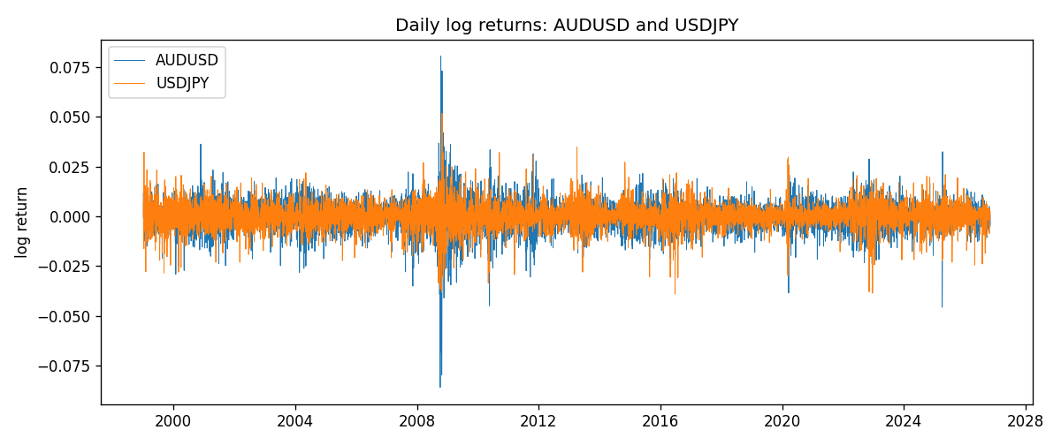
DCC rho path with Pearson r reference
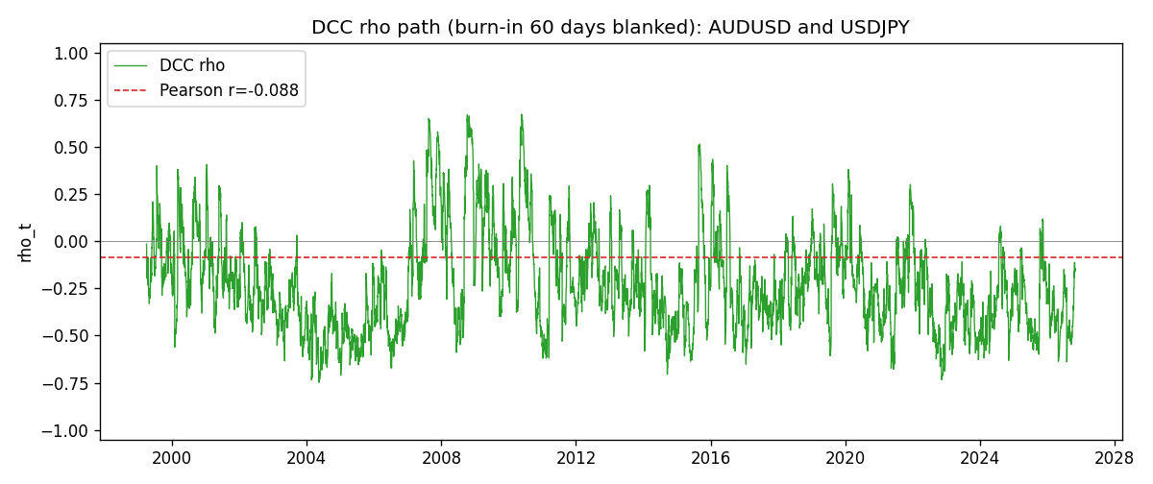

Data report
Every matched row that entered the DCC recursion is stored in the sibling Excel workbook named AUDUSD-USDJPY_DCC_D1.xlsx. Embedding all rows as a Word table is impractical at this length; the Word file holds the column list, column summaries, and the first and last 15 matched rows.
Columns: time, AUDUSD_open, USDJPY_open, AUDUSD_high, USDJPY_high, AUDUSD_low, USDJPY_low, AUDUSD_close, USDJPY_close, AUDUSD_tick_volume, USDJPY_tick_volume, AUDUSD_spread, USDJPY_spread, AUDUSD_real_volume, USDJPY_real_volume, AUDUSD_log_return, USDJPY_log_return, AUDUSD_sigma, USDJPY_sigma, AUDUSD_z, USDJPY_z, q11, q22, q12, rho_t
Column summaries (matched calculation rows)
column | count | mean | std | min | 25% | 50% | 75% | max
AUDUSD_open | 7199 | 0.75196998 | 0.13527571 | 0.4785 | 0.661035 | 0.73142 | 0.809135 | 1.10284
USDJPY_open | 7199 | 113.81114 | 19.206896 | 75.693 | 104.4285 | 110.984 | 120.6925 | 163.824
AUDUSD_high | 7199 | 0.75602148 | 0.13583632 | 0.4878 | 0.6647 | 0.7349 | 0.815325 | 1.10795
USDJPY_high | 7199 | 114.30872 | 19.268446 | 76.001 | 104.881 | 111.442 | 121.26 | 163.978
AUDUSD_low | 7199 | 0.7479145 | 0.13459018 | 0.4775 | 0.6577 | 0.72758 | 0.80425 | 1.0975
USDJPY_low | 7199 | 113.28779 | 19.134887 | 75.402 | 103.89 | 110.53 | 120.17 | 163.628
AUDUSD_close | 7199 | 0.75202255 | 0.13525884 | 0.4786 | 0.661195 | 0.73175 | 0.809235 | 1.10169
USDJPY_close | 7199 | 113.824 | 19.222288 | 75.811 | 104.42 | 111.025 | 120.687 | 163.851
AUDUSD_tick_volume | 7199 | 77366.826 | 138149.99 | 109 | 5440 | 43349 | 71344.5 | 1234623
USDJPY_tick_volume | 7199 | 106151.62 | 179316.41 | 197 | 9927 | 53098 | 92761 | 1803508
AUDUSD_spread | 7199 | 30.814558 | 16.886804 | 0 | 13 | 30 | 50 | 50
USDJPY_spread | 7199 | 20.321434 | 17.631726 | 0 | 6 | 11 | 30 | 50
AUDUSD_real_volume | 7199 | 5.2435469e+09 | 1.2539788e+11 | 0 | 0 | 0 | 0 | 3.811512e+12
USDJPY_real_volume | 7199 | 3.470603e+10 | 1.6078743e+11 | 0 | 0 | 0 | 0 | 3.8834203e+12
AUDUSD_log_return | 7199 | 2.78e-05 | 0.00754502 | -0.08602525 | -0.00385397 | 0.00028846 | 0.00415332 | 0.0806166
USDJPY_log_return | 7199 | 4.761e-05 | 0.00620532 | -0.03908203 | -0.00320306 | 0.00011368 | 0.00340781 | 0.05184024
AUDUSD_sigma | 7199 | 0.00693999 | 0.00279439 | 0.00390781 | 0.00551245 | 0.00627103 | 0.00758652 | 0.03855342
USDJPY_sigma | 7199 | 0.00599245 | 0.00173986 | 0.00337295 | 0.00477751 | 0.0056926 | 0.00679212 | 0.01882923
AUDUSD_z | 7199 | -0.00471671 | 1.0001103 | -8.4778463 | -0.60293061 | 0.04002593 | 0.63668686 | 5.0095292
USDJPY_z | 7199 | -0.00896639 | 1.0002805 | -6.5291937 | -0.56466322 | 0.00059696 | 0.58102451 | 7.1033166
q11 | 7199 | 1.0004902 | 0.29711135 | 0.53379086 | 0.8228243 | 0.94297897 | 1.0971161 | 5.1885993
q22 | 7199 | 1.001017 | 0.33826354 | 0.43122079 | 0.7845064 | 0.92606905 | 1.1261314 | 3.7418992
q12 | 7199 | -0.20943656 | 0.3061403 | -1.6944294 | -0.39102642 | -0.23515383 | -0.07539564 | 1.8102178
rho_t | 7199 | -0.22521948 | 0.25918533 | -0.74824544 | -0.41789961 | -0.26284975 | -0.08417275 | 0.67180216
First 15 matched rows (selected columns)
time | AUDUSD_log_return | USDJPY_log_return | AUDUSD_sigma | USDJPY_sigma | AUDUSD_z | USDJPY_z | q11 | q22 | q12 | rho_t
1999-01-05 | -0.00080418179 | -0.00017868311 | 0.0062618914 | 0.011227629 | -0.13443638 | -0.025685674 | 1 | 1 | -0.2093086 | -0.2093086
1999-01-06 | 0.011836351 | 0.0075660159 | 0.0061088003 | 0.010881564 | 1.9314277 | 0.6852241 | 0.94020171 | 0.93914126 | -0.19635164 | -0.20895779
1999-01-07 | 0.0088650256 | -0.012851583 | 0.0065427341 | 0.010683641 | 1.3491885 | -1.2131902 | 1.1114895 | 0.91193374 | -0.10409289 | -0.10339195
1999-01-08 | 0.00031515916 | -0.0047719894 | 0.0066885398 | 0.010770111 | 0.041491112 | -0.45326324 | 1.1521073 | 0.94804397 | -0.1998396 | -0.19121451
1999-01-11 | 0.0072213815 | -0.016195423 | 0.0065162185 | 0.010499081 | 1.1024396 | -1.5530053 | 1.078573 | 0.90400832 | -0.18903132 | -0.19143564
1999-01-12 | -0.0048608485 | 0.032310364 | 0.006559866 | 0.0108365 | -0.74673669 | 2.9714998 | 1.0851079 | 0.99802706 | -0.28224776 | -0.27122073
1999-01-13 | -0.0078902098 | 0.0081373171 | 0.0064898693 | 0.012816903 | -1.2215737 | 0.62633003 | 1.0510387 | 1.4750194 | -0.39852216 | -0.32006948
1999-01-14 | -0.002696916 | 0 | 0.0065803148 | 0.012549788 | -0.41556678 | -0.0087416711 | 1.0767408 | 1.3982237 | -0.41652159 | -0.33946391
1999-01-15 | 0.007123101 | 0.0055343401 | 0.0064423462 | 0.012157633 | 1.0998255 | 0.44619162 | 1.0199312 | 1.303975 | -0.38619792 | -0.33488051
1999-01-18 | 0.00094592471 | 8.7600193e-05 | 0.006485475 | 0.011843819 | 0.14004842 | -0.0018664528 | 1.0310272 | 1.2297398 | -0.32875022 | -0.29196069
1999-01-19 | 0.0072225153 | -0.0056219403 | 0.0063240717 | 0.011476089 | 1.1361147 | -0.49944248 | 0.96872394 | 1.1495985 | -0.30601527 | -0.28998129
1999-01-20 | 0.0012507819 | -0.0053879917 | 0.0063813077 | 0.011197726 | 0.19010801 | -0.49096556 | 0.98905034 | 1.0913603 | -0.31972414 | -0.30773872
1999-01-21 | 0.00078094498 | 0.0084664056 | 0.0062267199 | 0.010924708 | 0.11937277 | 0.76493573 | 0.93126949 | 1.0374887 | -0.30341336 | -0.30867774
1999-01-22 | -0.012252745 | 0.0060412564 | 0.0060743486 | 0.01075922 | -2.0233263 | 0.5512993 | 0.87699511 | 1.0090834 | -0.27722382 | -0.29469205
1999-01-25 | -0.0039591468 | -0.0073594164 | 0.0065601323 | 0.010516746 | -0.60925464 | -0.71021229 | 1.0757099 | 0.96593275 | -0.32671891 | -0.32051861
Last 15 matched rows (selected columns)
time | AUDUSD_log_return | USDJPY_log_return | AUDUSD_sigma | USDJPY_sigma | AUDUSD_z | USDJPY_z | q11 | q22 | q12 | rho_t
2026-10-13 | 0.0035007712 | -0.0018932826 | 0.0045170766 | 0.0048724646 | 0.76667439 | -0.41108327 | 0.74919918 | 0.6425317 | -0.24513784 | -0.35331691
2026-10-14 | -0.0015193215 | 7.5800166e-05 | 0.0045042446 | 0.0047869387 | -0.34566632 | -0.0070830146 | 0.74510262 | 0.62186493 | -0.24858351 | -0.36518779
2026-10-15 | -0.0075447063 | -0.0018524319 | 0.0044359737 | 0.0046833171 | -1.7092866 | -0.41896331 | 0.71282995 | 0.59264095 | -0.23239815 | -0.35755583
2026-10-16 | 0.0033906408 | -0.00037976126 | 0.0046898076 | 0.0046060675 | 0.71495396 | -0.10626579 | 0.85390985 | 0.57655126 | -0.1741061 | -0.24813556
2026-10-19 | 0.0050859986 | 0.0034946841 | 0.0046624949 | 0.0045118589 | 1.0827582 | 0.75024021 | 0.8363762 | 0.55180731 | -0.16893473 | -0.24867056
2026-10-20 | 0.0034620426 | -0.0022546642 | 0.0047166289 | 0.0044874348 | 0.72602668 | -0.52688684 | 0.86057789 | 0.56272576 | -0.11009976 | -0.15821325
2026-10-21 | 0.0036066384 | -0.00032883504 | 0.0046904818 | 0.0044301512 | 0.7609014 | -0.098990112 | 0.84345742 | 0.55535825 | -0.12895854 | -0.18842213
2026-10-22 | -0.0012672558 | -0.0085942669 | 0.0046715311 | 0.0043436912 | -0.27933027 | -2.0038195 | 0.83092892 | 0.53229844 | -0.12752885 | -0.19175598
2026-10-23 | 0.0023765656 | 0.00035080446 | 0.0045910996 | 0.0046999221 | 0.50944689 | 0.05129837 | 0.78894274 | 0.75510032 | -0.087545104 | -0.11342448
2026-10-26 | -0.0032032829 | 0.0041238746 | 0.0045362757 | 0.0046004701 | -0.71444668 | 0.87255615 | 0.76152705 | 0.71487399 | -0.083405599 | -0.11304147
2026-10-27 | 0.0016669876 | 0.0027651658 | 0.0045136395 | 0.0045972235 | 0.36098218 | 0.57762248 | 0.75168706 | 0.72422234 | -0.11916841 | -0.16151268
2026-10-28 | 0.0040915541 | -0.00095679538 | 0.0044462723 | 0.0045425884 | 0.91175475 | -0.23477837 | 0.71952199 | 0.70674083 | -0.10127359 | -0.14201823
2026-10-29 | -0.0040915541 | -0.00038043789 | 0.0044639142 | 0.0044565018 | -0.92501741 | -0.10998403 | 0.73274046 | 0.67376155 | -0.11061177 | -0.1574248
2026-10-30 | 0.0010102376 | -0.0010596481 | 0.004483985 | 0.0043691146 | 0.21690381 | -0.26764101 | 0.7463353 | 0.64092441 | -0.099936086 | -0.14449471
2026-11-02 | -0.0049184984 | 0.0026438521 | 0.0044079154 | 0.0042926049 | -1.1243734 | 0.59035154 | 0.70954798 | 0.61446329 | -0.099885581 | -0.15127388

